1C - Financial – Lesson 2
Taxation – Calculating Taxable Income

Name: _________________

- What do we mean by taxable income?

- How do we calculate taxable income?

- John earns $84,000 p.a. as a school dentist. He travels 16000 km for work in his 2 litre Camry. He gave $50 to the Salvation Army and had $600 in self education expenses.

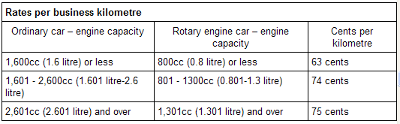
Taxable Income = Annual Income – Deductions

  - Calculate John’s deduction for travel.

Deduction = _______ km x _____ = $ _____

  - Calculate John’s Taxable Income.

Taxable Income = $ ________ - $ _______ - $_______ - $ _______ .

- Mary has a salary of $45,000 as a salesman. She has a deductions for super-annuation of $4,500, tax agent of $95, work related magazines of $300. Calculate her Taxable Income.

- A plumber earned $790 per week. She claims $6000 superannuation, 12% of her $70,000 car, gift of $300 and forestry management fees of $700.

  - Calculate the plumber’s deduction for the car.

Deduction = 0.12 x $ _______ =

  - Calculate her taxable income.

Taxable Income =

- Sam works part-time and earns $24000 per annum. If he/she claims bank charges on her investment loans of $350, superannuation contributions of $1500 and tax agent fees of $90.

Calculate his/her taxable income.

Taxable Income =

- Jim’s taxable income is $34000 and has deductions of $3500 for superannuation and $65 for a tax agent. Calculate her gross income.

